**Mode Card Software Architecture Design**

Compliance with ASPICE, ISO 26262, ISO/SAE 21434 Standards

☑ ASPICE-1/2/3/4/5 □ ASIL-A/B/C/D □ CAL-1/2/3/4

Issued by Ford ECDX

|  |  |  |  |
| --- | --- | --- | --- |
| Prepared by | Jiawei Li | Audited by |  |
| Reviewed by |  | Approved by |  |
| Issue By | Jiawei Li | Receiver |  |
| Deposit address |  | | |
| Upstream doc. |  | | |
| Downstream doc. |  | | |
| Secret Request | N/A | Text Format | N/A |
| Expire Years | 2037 | Current State | Draft×baseline×publish√ |

**Change History**

| Version | | Date | Author | Approve | Changes |
| --- | --- | --- | --- | --- | --- |
| Current | New |
| --- | 0.1 | 2022.12.21 | Li Jiawei |  | Initial Version |
| 0.1 | 0.2 | 2023.01.03 | Li Jiawei |  | 1. add key component description of static architecture  2. add key sequence diagram |
| 0.2 | 0.3 | 2023.01.09 | Li Jiawei |  | 1. update static architecture diagram  2. add “startup mode card process” sequence diagram  3. add “view recommend card list” sequence diagram  4. add “view custom card list” sequence diagram  5. add “run camp mode” sequence diagram  6. update “create a custom card mode” sequence diagram |
| 0.3 | 0.4 | 2023.01.15 | Li Jiawei |  | 1. add description of Startup component  2. add description of Home component  3. add “Terminate Camp Mode” sequence diagram  4. update description of Custom Mode component  5. update description of Card Manager component  6. update description of Trigger Manager component  7. update description of Executor Manager component  8. update description of Terminator Manager component  9. update “startup mode card process” sequence diagram  10. update “Create a custom Card Mode” sequence diagram  11. update “Run a Card Mode” sequence diagram  12. update “Terminate a Card Mode” sequence diagram  13. update “Run Camp Mode” sequence diagram |
|  |  |  |  |  |  |
|  |  |  |  |  |  |
|  |  |  |  |  |  |
|  |  |  |  |  |  |
|  |  |  |  |  |  |
|  |  |  |  |  |  |

List of content

1. Outline 5

1.1 Objectives 5

1.2 Reference documents 5

1.3 The definition of terms, abbreviations, and etc 5

2. Constraint Conditions 6

2.1 The Constraints of Hardware 6

2.2 The Constraints of Software 6

2.3 The Constraints of Manufacturing Process 6

2.4 The Constraints of Service and Maintenance After Shipment 6

3. Software Design 7

3.1 Software Static Architecture 7

3.1.1 External module dependencies diagram 7

3.1.2 Software Architecture Diagram 8

3.1.3 COMP_01: Startup 9

3.1.4 COMP_02: Home 9

3.1.5 COMP_03: Custom Mode 10

3.1.6 COMP_04: Card Manager 11

3.1.7 COMP_05: Trigger Manager 11

3.1.8 COMP_06: Executor Manager 12

3.1.9 COMP_07: Terminator Manager 13

3.2 Software Dynamic Architecture 14

3.2.1 Function 14

3.2.1.1 Startup Mode Card Process 14

3.2.1.2 View Recommend Card List 15

3.2.1.3 View Custom Card List 16

3.2.1.4 Create a custom Card Mode 17

3.2.1.5 Run a Card Mode 19

3.2.1.6 Terminate a Card Mode 19

3.2.1.7 Run Camp Mode 20

3.2.1.8 Terminate Camp Mode 21

3.2.2 Safety Mechanism_ASIL 24

4. Detailed Interface 24

4.1 Component Interface 24

4.2 Hardware – Software Interface 24

5. Software control Strategy 25

5.1 Time Constrains Design and Estimation 25

5.2 Task Management 25

5.3 Interrupt Service Routines 25

5.4 Initialization Processing 25

5.5 Watch Dog 25

5.6 Shared Resources 25

6. Resource Estimation 25

6.1 Memory Size Estimation 25

6.2 CPU Load Estimation CPU 25

# 

# Outline

## Objectives

This is Mode Card SW design to guide developer to implement features, forwarding is forbidden without concurred by author

## Reference documents

| No. | Reference Document. | Version | Issuer | Reason. |
| --- | --- | --- | --- | --- |
| 1 | Mode Card 1.0 PRD 场景卡片_ V1.1_20221215 | V1.1 | Geng Dekang |  |
| 2 | Camp Mode PRD_V1.1_20221212 | V1.0 | Ni Anthony |  |
| 3 | Pet Mode 0.3 PRD_ 20221216 | V0.3 | Hu Lina |  |
| 4 | Battery Save Mode 0.1 PRD_ 20221214 | V0.1 | Hu Lina |  |
| 5 | 【福特CX727】【CX727】 Mode Card and Camp Mode UE | V1.0 | Tao Yali |  |

## The definition of terms, abbreviations, and etc

| No. | Terms and Abbreviations. | Meanings, Definitions and Official Name. |
| --- | --- | --- |
| 1 | Co., Ltd. | Company Limited |
| 2 | CPU | Central Processing Unit |
| 3 | e.g. | exempli gratia |
| 4 | I/O | Input/Output |
| 5 | ISR | Interrupt Service Routine |
| 6 | OS | Operating Software |
| 7 | RAM | Random Access Memory |
| 8 | ROM | Read Only Memory |
| 9 | RTOS | RealTime Operating Software |
|  |  |  |
|  |  |  |

# Constraint Conditions



## The Constraints of Hardware

* CX727 ICA Bench，including Silver Box, Display Screen, DSP & Cables
* CX821 Bench，including Silver Box, Controller Screen , Pano Screen, DSP & Cables

## The Constraints of Software

## The Constraints of Manufacturing Process

* N/A

## The Constraints of Service and Maintenance After Shipment

* N/A

# Software Design



## Software Static Architecture



### External module dependencies diagram

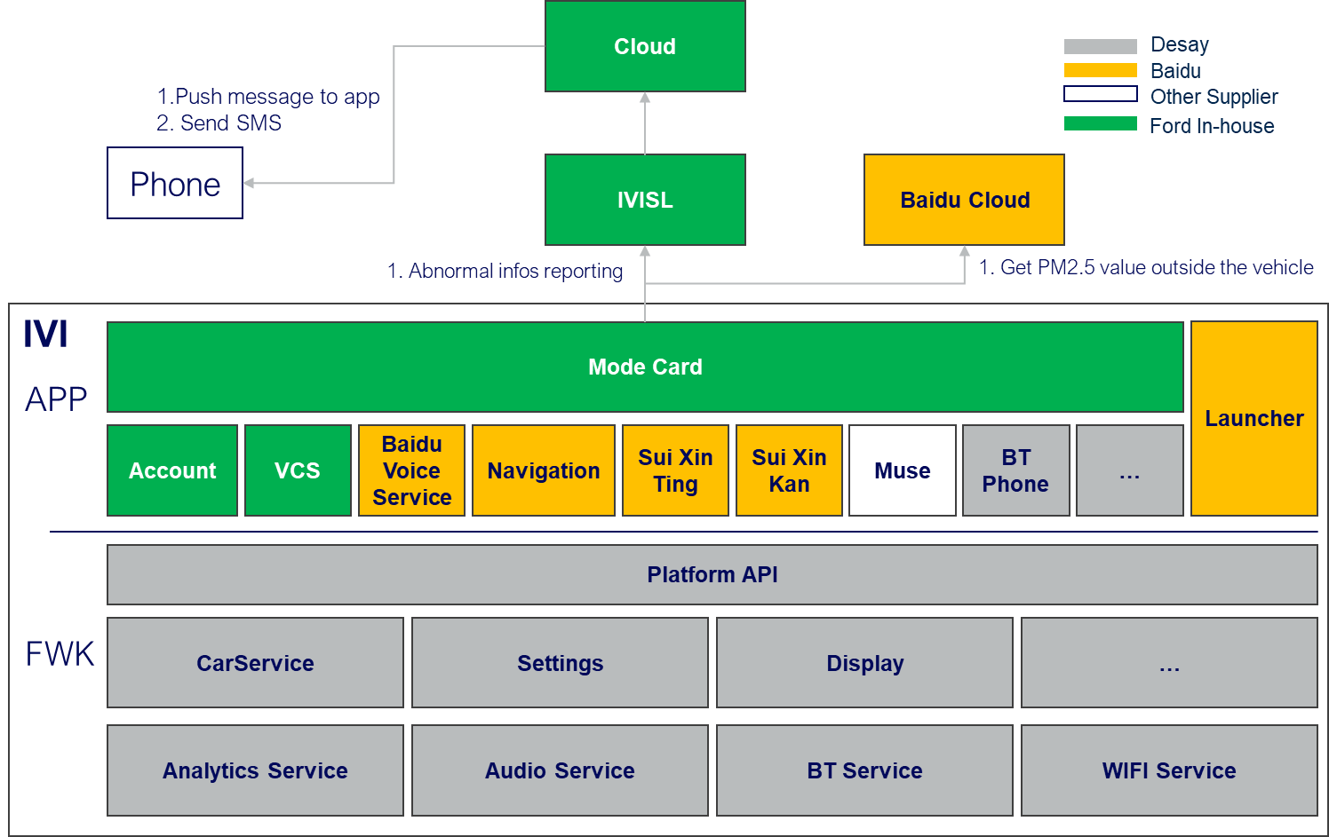

**CX727 ICA**

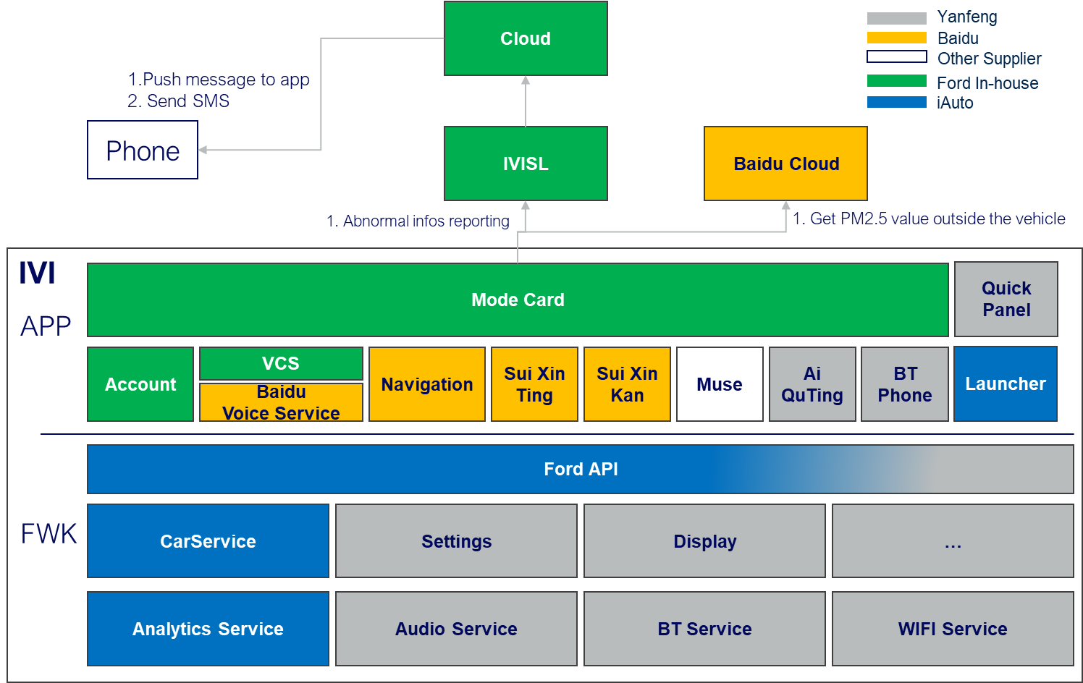

**CX821**

### Software Architecture Diagram

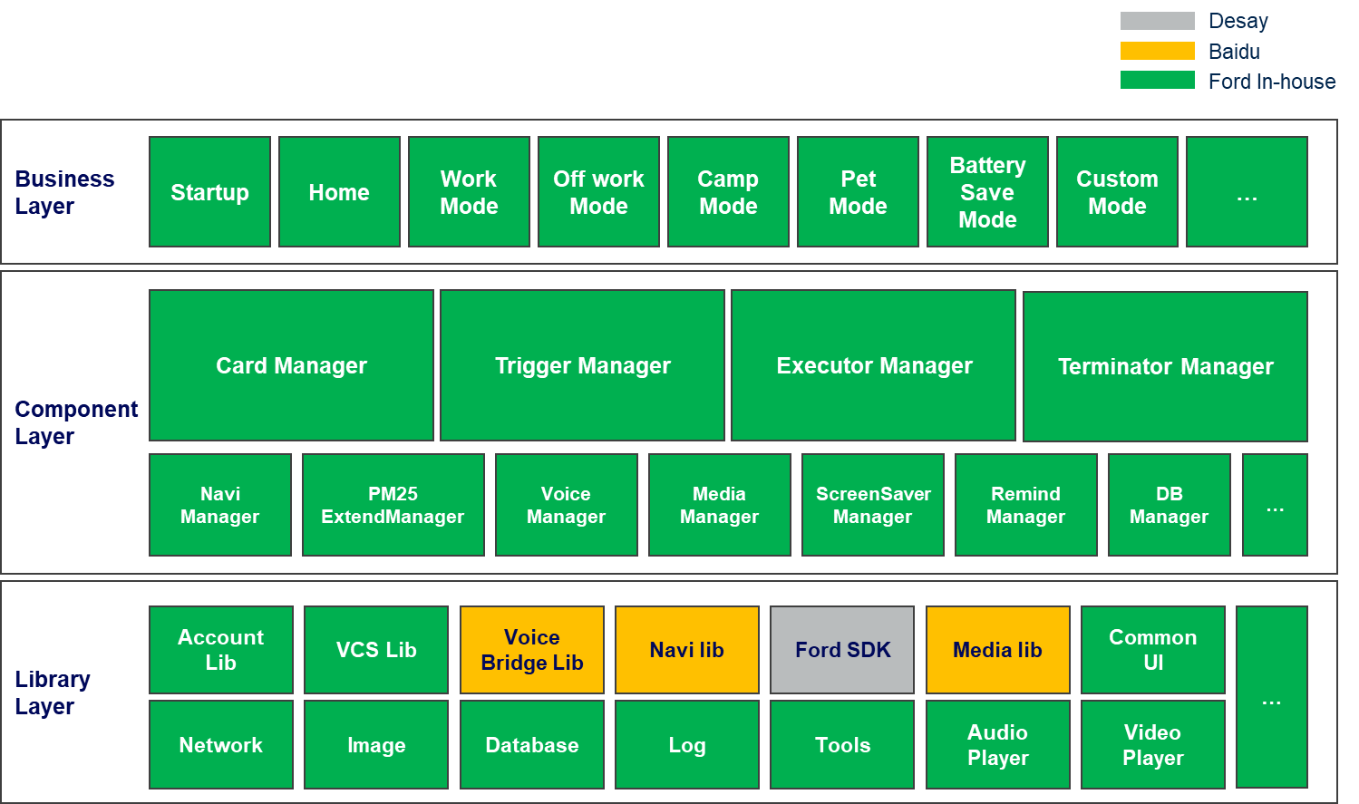

**CX727 ICA**

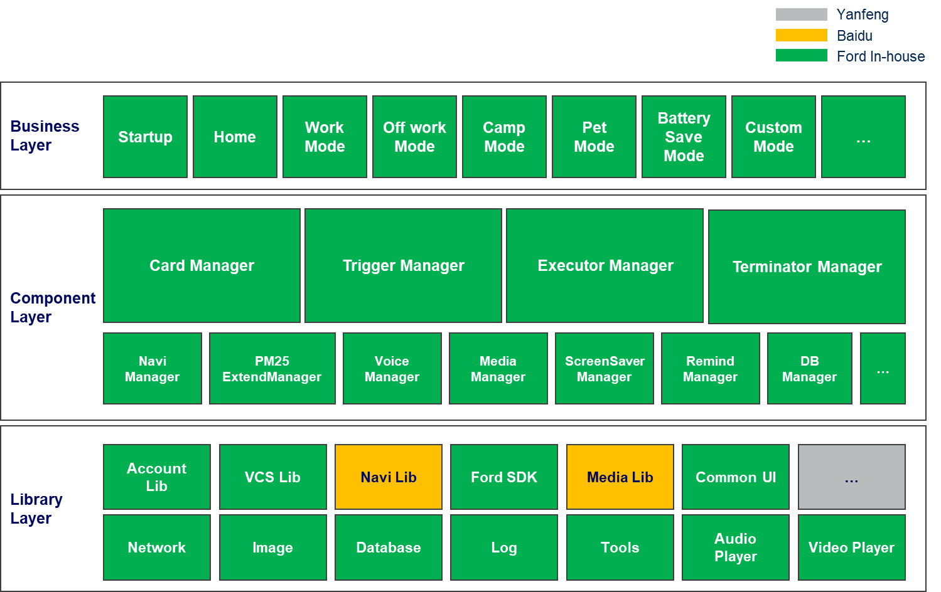

**CX821**

**抽象Card Mode形成Card Manager，Trigger Manager，Executor Manager，Terminator Manager四大组件。**

**设计原则：**

**四大组件自包含，松耦合，标准化南北向接口，横向接口，可以组合创建任意卡片模式，灵活支持业务层的扩展。**

### COMP_01: Startup

|  |  |  |
| --- | --- | --- |
| ID | | MODECARD_COMP_01 |
| Layer | | Mode Card Business Layer |
| Responsibility | | Startup Component |
| Req Allocation | | 1. 开机自启动 2. 初始化所有卡片数据并启用卡片 3. 初始化语音功能 4. 启动主页 |
| Source | | N/A |
| ASIL Class | | N/A |
| Resource Consumption | Flash | N/A |
| RAM | N/A |
| EEPROM | N/A |
| CPU | N/A |

### COMP_02: Home

|  |  |  |
| --- | --- | --- |
| ID | | MODECARD_COMP_02 |
| Layer | | Mode Card Business Layer |
| Responsibility | | Home Component |
| Req Allocation | | 1. 展示推荐卡片列表 2. 展示自定义卡片列表 |
| Source | | N/A |
| ASIL Class | | N/A |
| Resource Consumption | Flash | N/A |
| RAM | N/A |
| EEPROM | N/A |
| CPU | N/A |

### COMP_03: Custom Mode

|  |  |  |
| --- | --- | --- |
| ID | | MODECARD_COMP_03 |
| Layer | | Mode Card Business Layer |
| Responsibility | | Custom Mode Component |
| Req Allocation | | 1. 创建卡片 2. 编辑卡片 3. 查看卡片 4. 删除卡片 5. 手动运行卡片 6. 手动停止卡片 |
| Source | | N/A |
| ASIL Class | | N/A |
| Resource Consumption | Flash | N/A |
| RAM | N/A |
| EEPROM | N/A |
| CPU | N/A |

### COMP_04: Card Manager

|  |  |  |
| --- | --- | --- |
| ID | | MODECARD_COMP_04 |
| Layer | | Mode Card Component Layer |
| Responsibility | | Card Manager Component |
| Req Allocation | | 1. 获取所有卡片列表 2. 获取推荐卡片列表 3. 获取自定义卡片列表 4. 根据卡片名称获取卡片 5. 根据卡片ID获取卡片 6. 启用卡片自动触发功能 7. 禁用卡片自动触发功能 8. 创建新卡片（含默认参数） 9. 保存卡片 10. 更新卡片 11. 删除卡片 12. 重置卡片配置 13. 运行卡片 14. 终止卡片 |
| Source | | N/A |
| ASIL Class | | N/A |
| Resource Consumption | Flash | N/A |
| RAM | N/A |
| EEPROM | N/A |
| CPU | N/A |

### COMP_05: Trigger Manager

|  |  |  |
| --- | --- | --- |
| ID | | MODECARD_COMP_05 |
| Layer | | Mode Card Component Layer |
| Responsibility | | Trigger Manager Component |
| Req Allocation | | 1. 根据卡片ID获取所有条件（条件ID，条件值） 2. 根据条件ID获取条件信息 3. 根据卡片ID获取所有条件信息 4. 启用触发器（开启自动，注册自动触发条件） 5. 禁用触发器（关闭自动） 6. 校验运行环境 7. 创建卡片触发器 8. 添加卡片触发条件 9. 编辑卡片触发条件 10. 重置卡片触发条件 11. 获取所有的触发条件列表 |
| Source | | N/A |
| ASIL Class | | N/A |
| Resource Consumption | Flash | N/A |
| RAM | N/A |
| EEPROM | N/A |
| CPU | N/A |

### COMP_06: Executor Manager

|  |  |  |
| --- | --- | --- |
| ID | | MODECARD_COMP_06 |
| Layer | | Mode Card Component Layer |
| Responsibility | | Executor Manager Component |
| Req Allocation | | 1. 根据卡片ID获取所有任务（任务ID,任务值） 2. 根据任务ID获取任务信息 3. 根据卡片ID获取所有任务信息 4. 创建卡片执行器 5. 添加卡片执行任务 6. 编辑卡片执行任务 7. 重置卡片执行任务 8. 查询所有任务列表 9. 执行任务 |
| Source | | N/A |
| ASIL Class | | N/A |
| Resource Consumption | Flash | N/A |
| RAM | N/A |
| EEPROM | N/A |
| CPU | N/A |

### COMP_07: Terminator Manager

|  |  |  |
| --- | --- | --- |
| ID | | MODECARD_COMP_07 |
| Layer | | Mode Card Component Layer |
| Responsibility | | Terminator Manager Component |
| Req Allocation | | 1. 根据卡片ID获取所有终止条件（条件ID,条件值） 2. 根据条件ID获取终止条件信息 3. 根据卡片ID获取所有终止条件信息 4. 启用终止器（注册自动终止条件） 5. 禁用终止器 6. 创建卡片终止器 7. 添加卡片终止条件 8. 查询所有终止条件列表 |
| Source | | N/A |
| ASIL Class | | N/A |
| Resource Consumption | Flash | N/A |
| RAM | N/A |
| EEPROM | N/A |
| CPU | N/A |

## Software Dynamic Architecture



### Function



#### Startup Mode Card Process

Startup mode card process

|  |  |
| --- | --- |
| ModeCard_Sequence_01 | Functions  Startup Mode Card Process |
| Operation outline  操作概要 | 1. 开机自启动 2. 初始化所有卡片数据并启用自动触发 3. 初始化语音功能 |

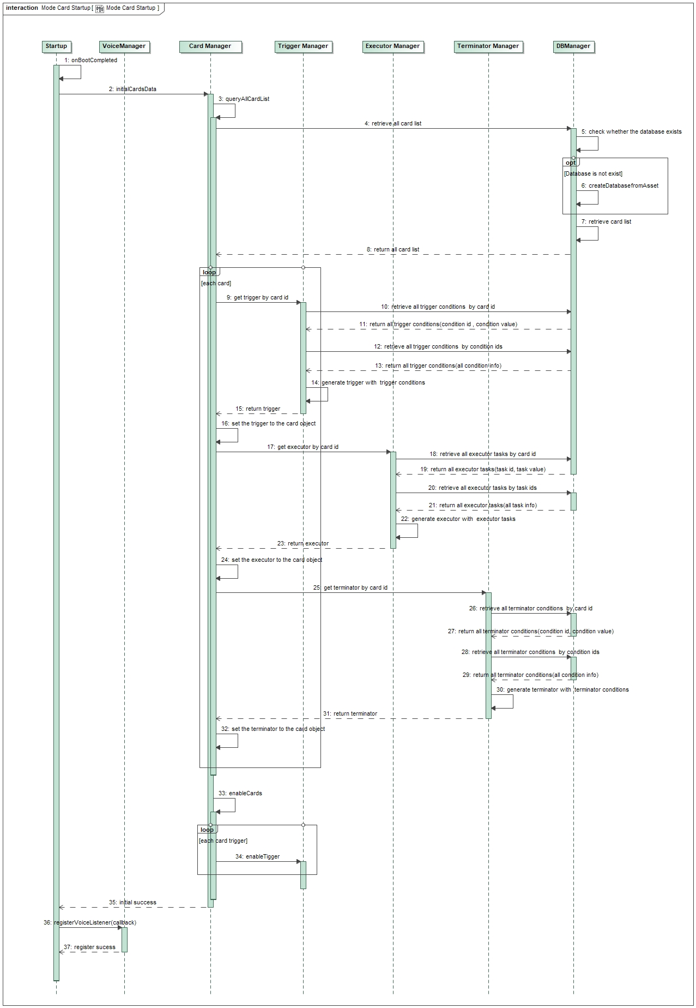

#### View Recommend Card List

View recommend card list

|  |  |
| --- | --- |
| ModeCard_Sequence_02 | Functions  View Recommend Card List |
| Operation outline  操作概要 | 1. 手动打开/语音打开主页 2. 获取推荐卡片列表 3. 展示推荐卡片列表 |

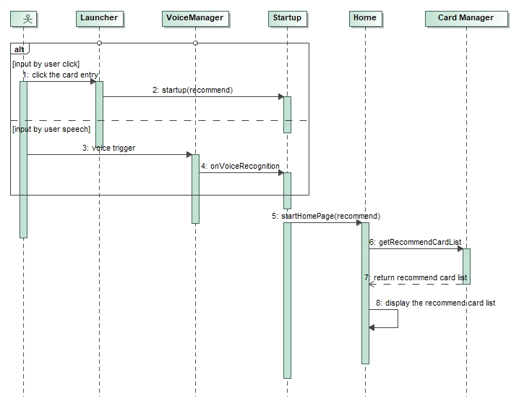

#### View Custom Card List

View custom card list

|  |  |
| --- | --- |
| ModeCard_Sequence_03 | Functions  View Custom Card List |
| Operation outline  操作概要 | 1. 手动打开/语音打开自定义卡片页 2. 获取自定义卡片列表 3. 展示自定义卡片列表 |

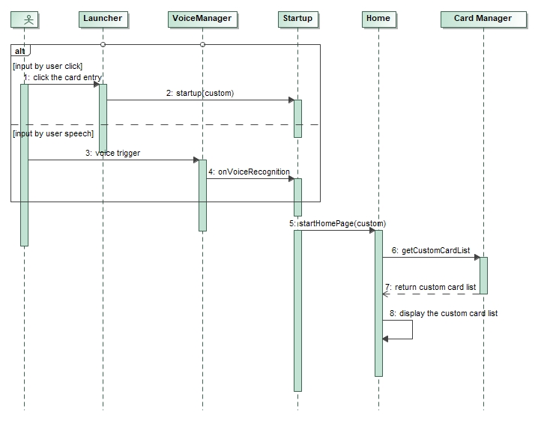

#### Create a custom Card Mode

Create a custom Card Mode

|  |  |
| --- | --- |
| ModeCard_Sequence_04 | Functions  Create a custom Card Mode |
| Operation outline  操作概要 | 1. 创建一个空白卡片 2. 设置卡片名称 3. 设置卡片运行方式 4. 设置运行触发条件 5. 设置运行周期 6. 设置运行询问开关 7. 设置运行任务 8. 设置终止方式 9. 保存卡片 10. 启用卡片 |

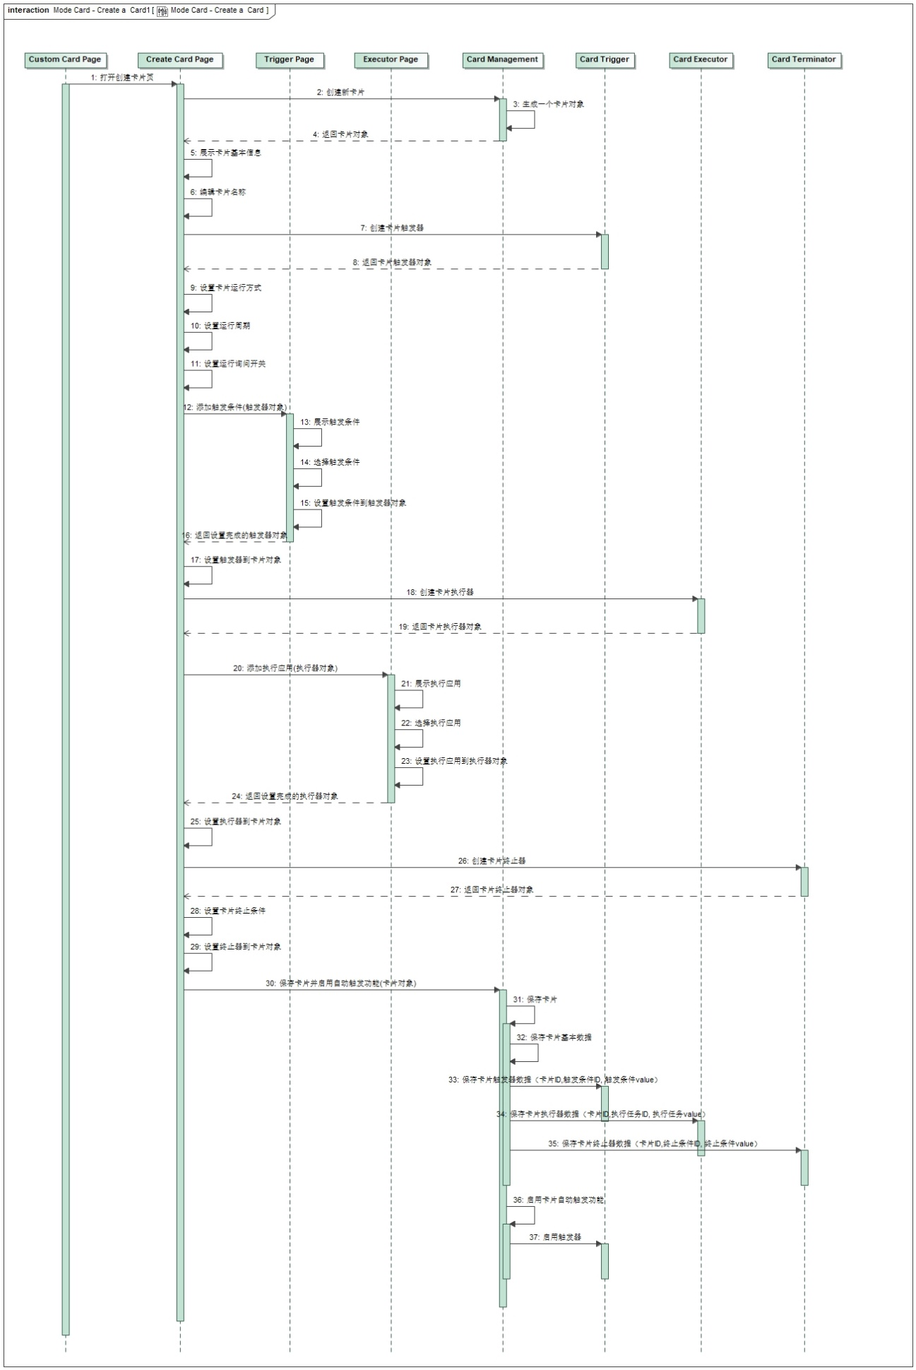

#### Run a Card Mode

Run a Card Mode

|  |  |
| --- | --- |
| ModeCard_Sequence_05 | Functions  Run a Card Mode |
| Operation outline  操作概要 | 1. 手动/语音/自动运行卡片 2. 运行环境校验 3. 缓存当前的座舱设置 4. 执行卡片任务 |

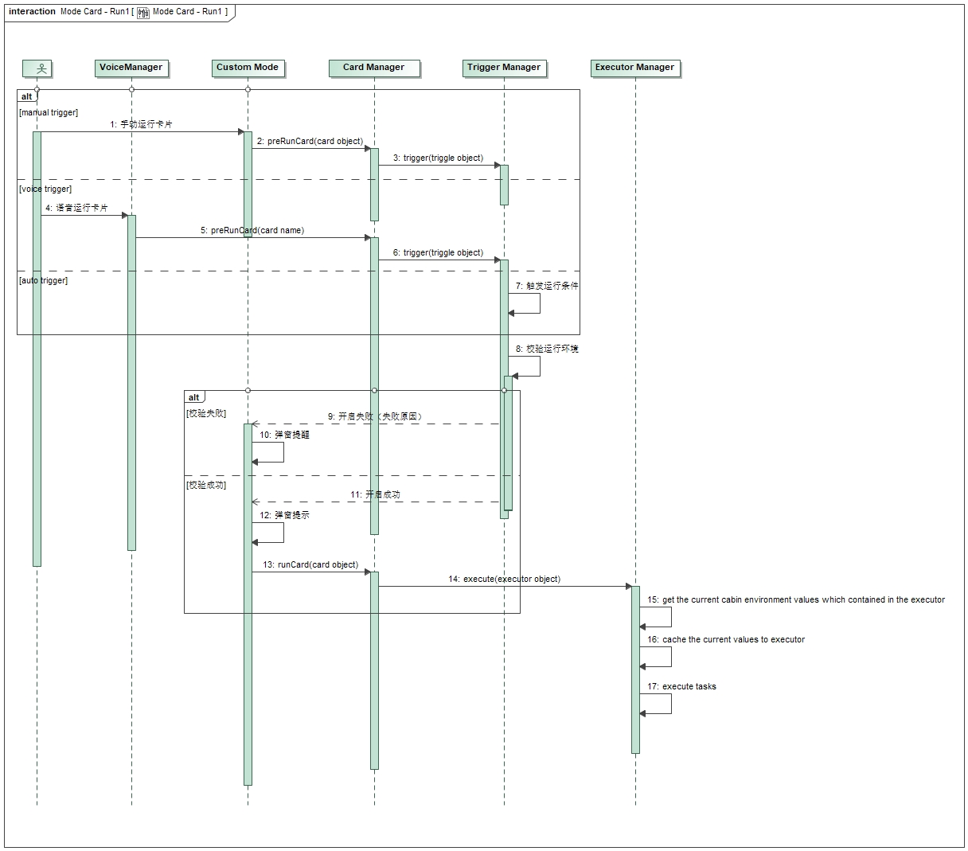

#### Terminate a Card Mode

Terminate a Card Mode

|  |  |
| --- | --- |
| ModeCard_Sequence_06 | Functions  Terminator a Card Mode |
| Operation outline  操作概要 | 1. 手动/语音/自动终止卡片 2. 终止正在运行的任务 3. 恢复座舱设置 |

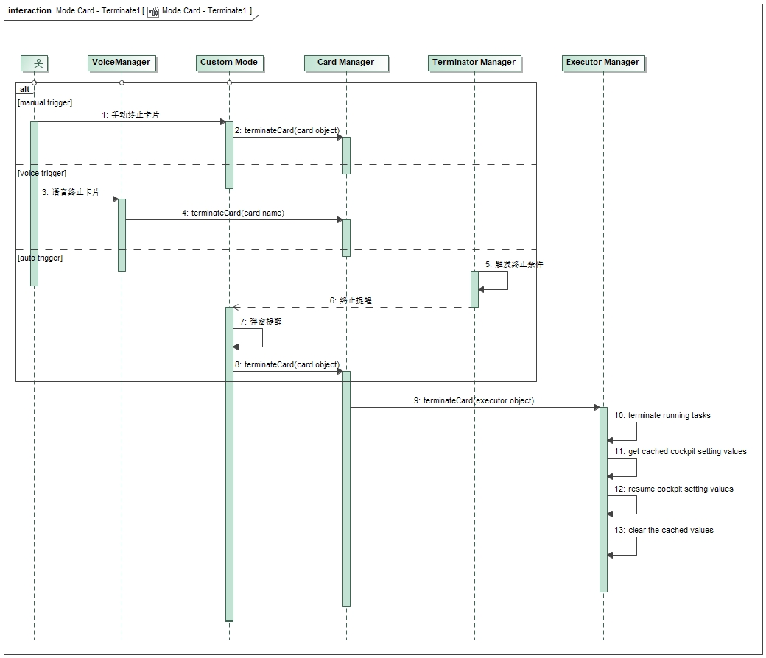

#### Run Camp Mode

Run Camp Mode

|  |  |
| --- | --- |
| ModeCard_Sequence_07 | Functions  Run Camp Mode |
| Operation outline  操作概要 | 1. 手动/语音开启Camp Mode 2. 运行环境校验：   剩余电量>30%,  点火状态为运行态，  档位为P档，  电子手刹已拉起  校验失败提醒  校验成功提示   1. 缓存当前的座舱设置   AEIS状态，  空调状态，  蓝牙电话私密模式状态   1. 运行Camp Mode:   TTS播报，  关闭AEIS,  关闭日行灯，  设置空调，  设置蓝牙电话私密模式，  开启屏保，  熄屏 |

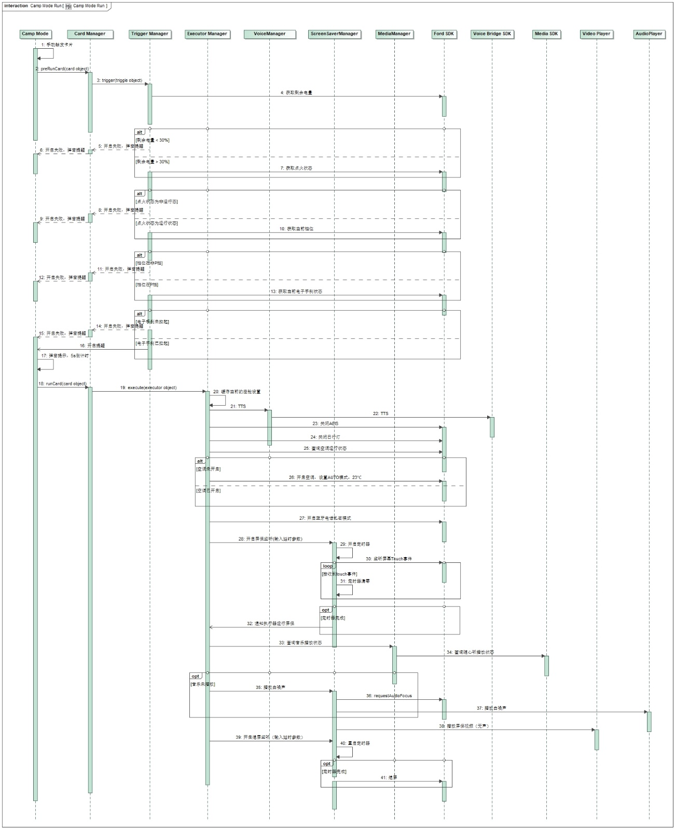

#### Terminate Camp Mode

Terminate Camp Mode

|  |  |
| --- | --- |
| ModeCard_Sequence_08 | Functions  Terminator a Card Mode |
| Operation outline  操作概要 | 1. 手动/语音/自动终止卡片 2. 终止正在运行的任务   退出熄屏/退出屏保   1. 恢复座舱设置   根据缓存状态恢复AEIS,  打开日行灯,  根据缓存状态恢复空调设置,  根据缓存状态恢复蓝牙电话模式 |

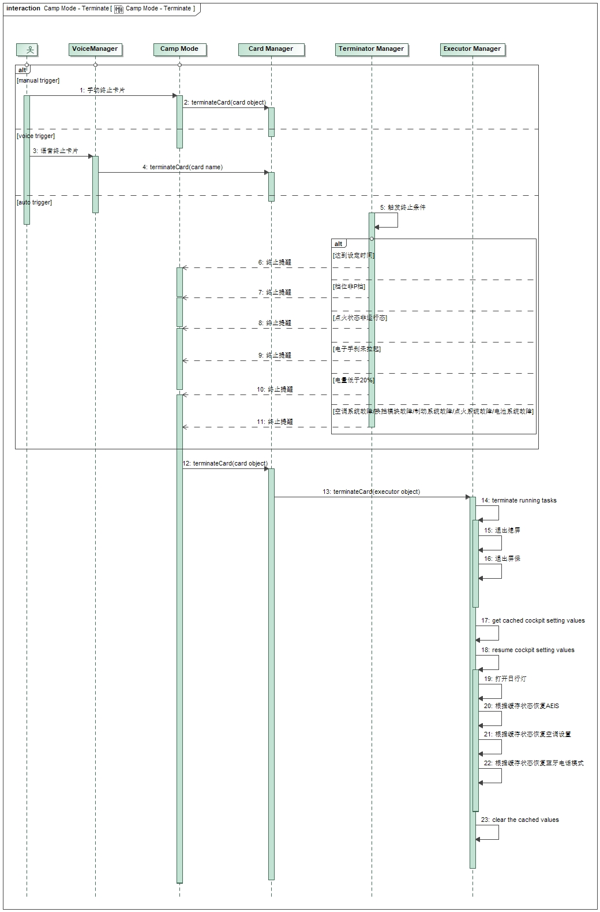



### Safety Mechanism_ASIL

N/A

# Detailed Interface

## Component Interface

## 4.2 Hardware – Software Interface

N/A

# Software control Strategy

## Time Constrains Design and Estimation



## Task Management

N/A

*I*

## Interrupt Service Routines

N/A

## Initialization Processing

## Watch Dog

N/A

## Shared Resources

N/A

# Resource Estimation

## Memory Size Estimation

## CPU Load Estimation CPU